./

Learning Report – C, Linux & OS Programming



|  |  |  |  |  |  |
| --- | --- | --- | --- | --- | --- |
| **Ver. Rel. No.** | **Release Date** | **Prepared. By** | **Reviewed By** | **To be approved By** | **Remarks/Revision Details** |
| 1 |  | Name/PS No | Name/PS No | Module Owner Name | Comments |
| 2 | 15/02/21 | Shivanshu/99003731 |  |  |  |

**Document History**

Table of Contents

Table of Figures 3

ACTIVITY 1: BOXES (GROUP ACTIVITY) 4

Requirements 4

Introduction 4

MAKE FILE RULES 4

GIT COMMITS 5

DOXYGEN FILE 5

REFERENCES 6

ACTIVITY 2: LINUX OS PROGRAMMING 6

THEME 6

EPIC 6

USER STORY 6

BASIC SYSTEM CALLS: 7

PROCESS AND EXEC CALLS: 7

THREADING: 7

SEMAPHORE AND MUTEX: 7

MESSAGE QUEUE AND PIPES: 7

SHARED MEMORY: 7

## Table of Figures

**figure 1 1.GIT COMMITS**

**figure 1 2. DOXYGEN MARKDOWN FILE**

# ACTIVITY 1: BOXES (GROUP ACTIVITY)

[https://github.com/99003738/define_box.git (Link](https://github.com/99003733/SDLC_N2_Calculator.git%20(Link) to GITHUB REPOSITORY)

# Requirements

1.Valgrind

2. GDB

3.MAKE

4.Visual Studio Code

5.Linux

# Introduction

In this activity we worked as a team wrote code using c programming for array of boxes where box is a structure with various parameters and various functions to access it for certain criteria’s. Here I implemented the code for adding data for extra boxes at the end and also method to calculate the difference in minimum and maximum volume of array of boxes.

# MAKE FILE RULES

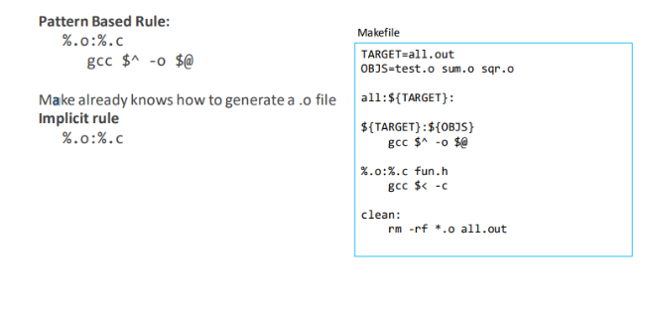

## GIT COMMITS

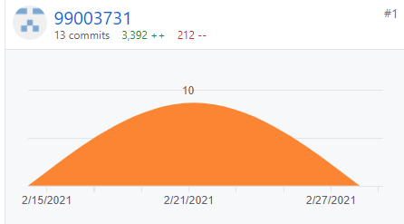

figure1 . GIT COMMITS

## DOXYGEN FILE

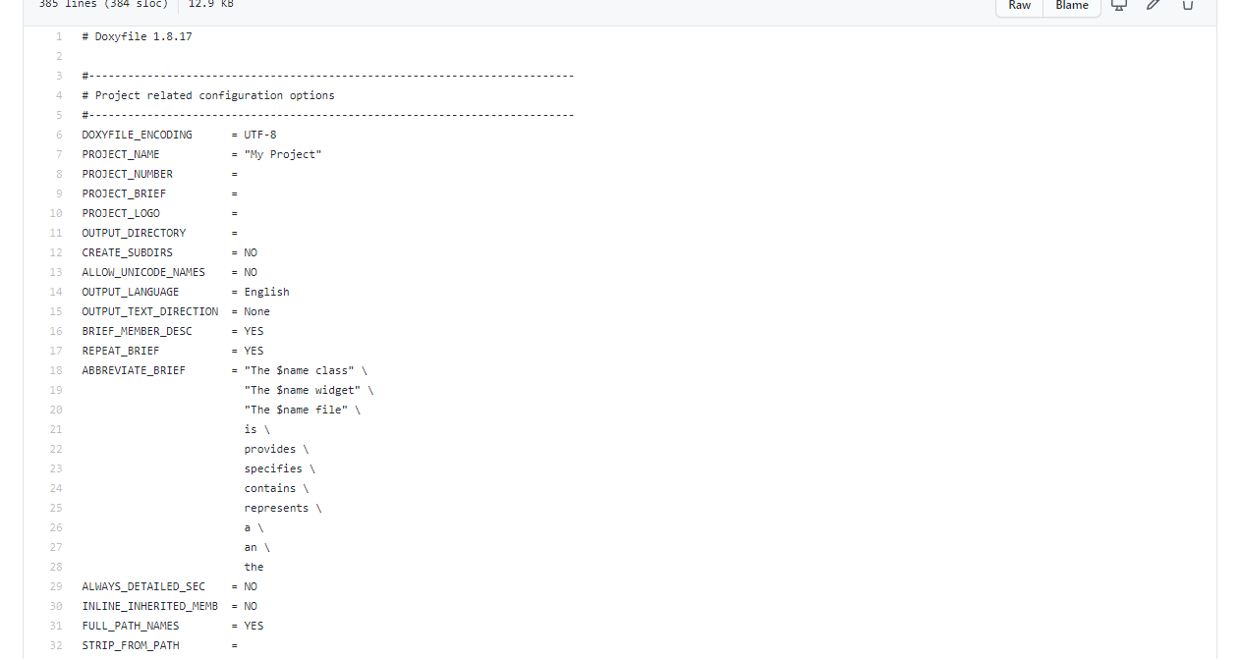

**figure 1 2. DOXYGEN MARKDOWN FILE**

# REFERENCES

1. https://github.com/adam-p/markdown-here/wiki/Markdown-Cheatsheet)

2. https://guides.github.com/features/mastering-markdown/)

3. https://github.com/ejwa/gitinspector.git

4. https://docs.github.com/en/actions/learn-github-action

5. https://stackedit.io/app#

6. https://creately.com/

# ACTIVITY 2: LINUX OS PROGRAMMING

# THEME

Learnt basic terminal commands, then learnt about system calls, child and parent process using fork, use of exec commands , threading, semaphore, mutex, message queue and shared memory programming for developing API’s using C,

# EPIC

Epic according to the requirements provided are:

1. Basic System Calls.
2. Process and Exec calls.
3. Threading.
4. Semaphores and Mutex.
5. Message Queue and Pipes.
6. Shared Memory.

# USER STORY

## BASIC SYSTEM CALLS:

1. Open, read, write, close, signals these commands were learnt.

## PROCESS AND EXEC CALLS:

1. Creation of multiple child and parent process in same program using fork ().
2. Calling child process of other sources files using in exec system calls.

## THREADING:

1. Threading used to connect variable data for child and parent process.

2. pthread.h library introduced.

## SEMAPHORE AND MUTEX:

1. Mutex system call is for monotonically sequencing data like it works as half duplex communication.

2. Semaphores used to sequence data in two –way communication but one after the another only.

## MESSAGE QUEUE AND PIPES:

1. Message is sent and received using First in and First Out concept.

## SHARED MEMORY:

1. Memory is shared between parent and child or child and child process.

2. This is the most fastest way of parent and child to communicate.